ASSIGNMENT SESSION-3
1. Declare variables for a Flipkart product: productName (as a string), price (float), and rating (double). Assign sample values and print each variable with its data type.
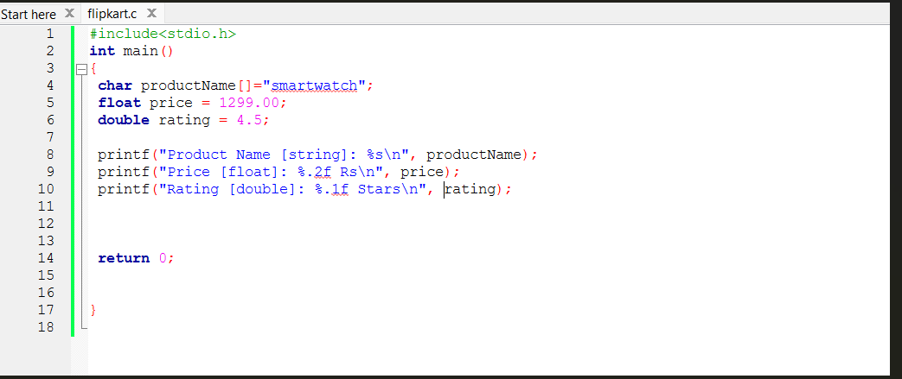OUTPUT:
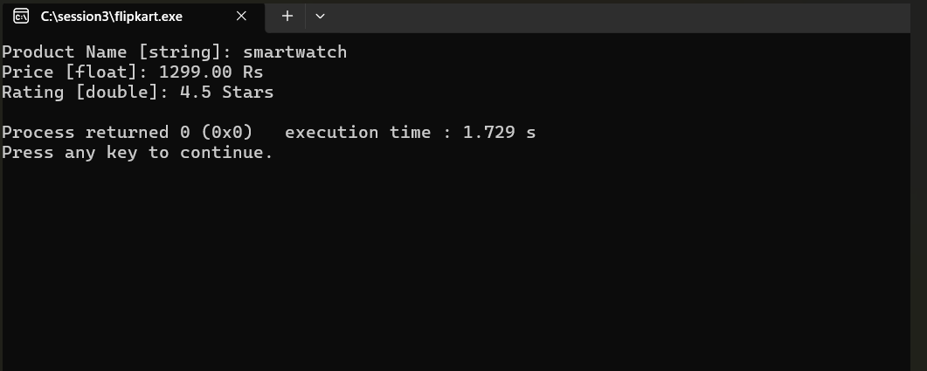

2. Create a constant variable to store the GST rate (for example, 18%) and use it to calculate the final price of a Zomato order with a given base price.<br><br><em><strong>Constraint:</strong> The GST rate must not be changeable after its initial assignment.</em>
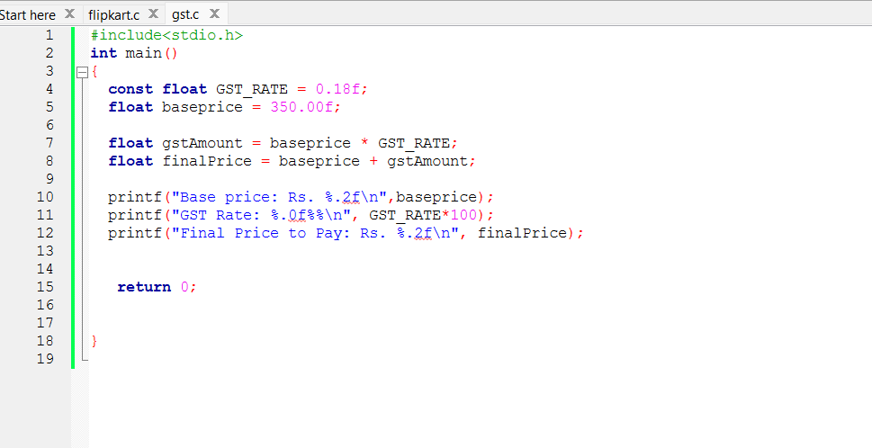
OUTPUT:
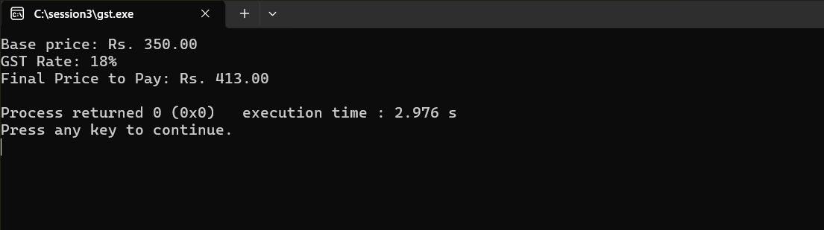

3. Write a program that stores your favorite Spotify playlist's name (string), total number of songs (int), and average song duration in minutes (float). Print all values in a single formatted sentence.
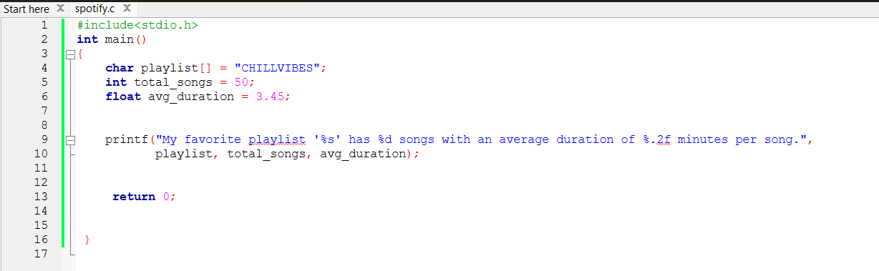
OUTPUT:
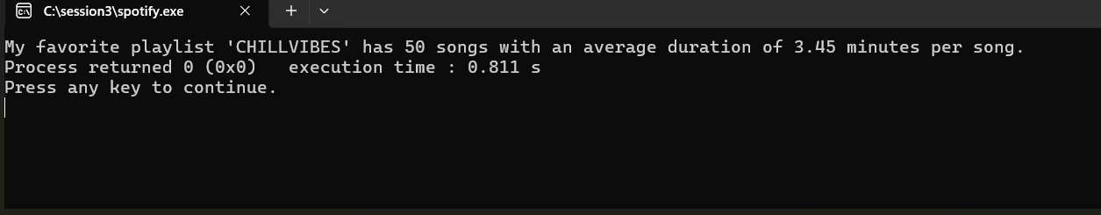

4. Identify and correct the invalid variable names from this list: 1stPlayer, player_age, $score, total-marks, userName.<br><br><em><strong>Hint:</strong> Apply standard variable naming rules for your programming language.</em>.
Variable name | Valid/Invalid | correction
1stPlayer | Invalid | firstPlayer
player_age | valid | Player_age
$score | Invalid | score
Total-marks | Invalid | Total_marks
userName | Valid | userName

